Dashboard Design
Date | 30 July 2026
Team ID | Archana kumari
Project Name | Food ordering behaviour and consumer trends
Maximum Marks | 5 Marks

Activity 1: Interactive and Visually Appealing Dashboards

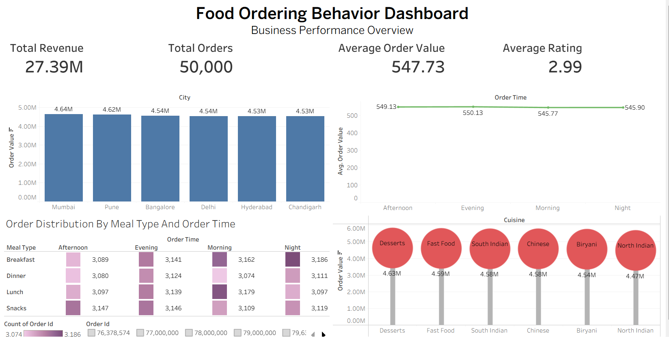
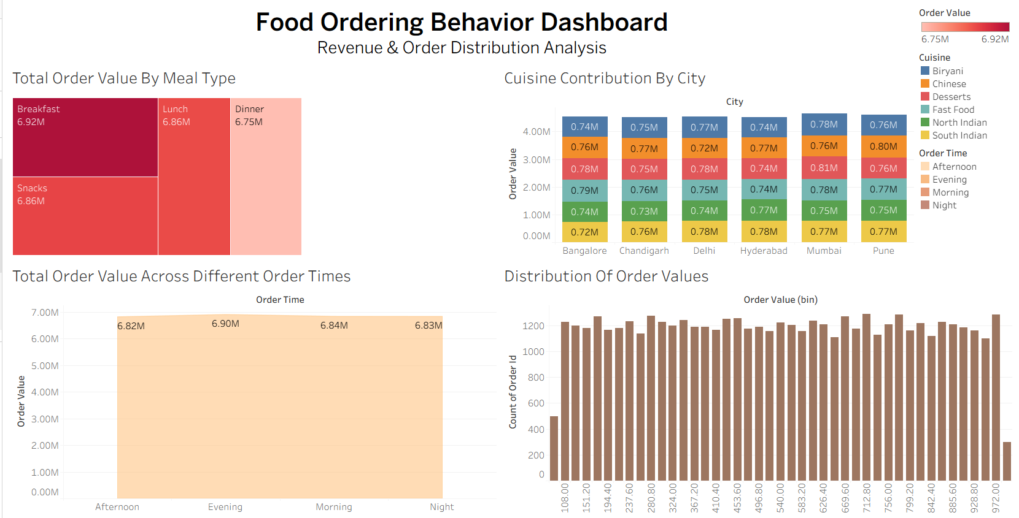

The core design principles—including a Clear and Intuitive Layout, Consistent Color and Theming, Interactive Analysis, and Effective Data Visualization—have been applied to create the Food Ordering Behavior Analysis Dashboard. Below are the key outcomes and insights surfaced by the analytical interface:
City-wise Revenue Performance (Q1): The Total Order Value by City bar chart compares revenue contribution across different cities and helps identify the strongest-performing markets. This provides a basis for evaluating market potential and supporting decisions related to marketing, expansion, and resource allocation.
Order Value by Time of Day (Q2 & Q3): The Average Order Value line chart and Total Order Value area chart highlight customer spending and revenue patterns across Morning, Afternoon, Evening, and Night. These visualizations help identify variations in customer ordering behavior throughout the day and support better promotional and operational planning.
Meal Preference and Ordering Patterns (Q4 & Q5): The Order Distribution heat map and Meal Type treemap reveal customer preferences across different meal types and order times. The analysis helps identify popular meal-time combinations and the relative revenue contribution of different meal categories, supporting menu planning and inventory decisions.
Customer Spending Distribution (Q6): The Order Value histogram illustrates how customer orders are distributed across different spending ranges. This provides a clearer understanding of common purchasing patterns and can support pricing, promotional, and customer-segmentation strategies.
Cuisine Contribution Across Cities (Q7): The stacked bar chart compares cuisine-wise order value across different cities, highlighting how individual cuisines contribute to overall city revenue. This helps identify regional preferences and supports localized menu and marketing strategies.
Cuisine-wise Revenue Performance (Q8): The Order Value by Cuisine lollipop chart provides a clear comparison of total order value across cuisine categories. It helps identify higher and lower revenue-generating cuisines and supports strategic decisions related to menu offerings and promotional focus.

Activity 2: Live Deployment Link
Below is the verified public access link to the interactive, cloud-hosted visualization story:
Tableau Public Dashboard Link:
https://public.tableau.com/views/food_ordering_behaviourdashboard1/BusinessPerformanceOverview?:language=en-US&publish=yes&:sid=&:redirect=auth&:display_count=n&:origin=viz_share_link
https://public.tableau.com/views/food_ordering_behaviourdashboard2/RevenueAndDistributionAnalysis?:language=en-US&publish=yes&:sid=&:redirect=auth&:display_count=n&:origin=viz_share_link

